Daily Progress Report

Installation / Location | PS-3
Subject | Corrosion Monitoring Activities
Contract Number | LC241047A0
Assigned Petromec Representatives | Shuaib Palakkavalappil
Date of Issue | 22-08-2025

Activities Summary
We arrived at PS-3 this morning and completed all required safety inductions. We then proceeded with submitting work permit and waiting for the permit to be live, mean while we transferred all retrieval tools to the location, We started the work when the permit at the live status
Work activities commenced today, starting with the retrieval and installation of ER PROBE where reported leaking, after the rectification of the location the work is stopped due to Rough Sea and came back to Halul.

Time | Activities
06:00 to 09:30 | Proceed to dock, board vessel to PS-3
09:30 to 10:45 | Complete platform safety induction, Submit the work permit, awaiting gas test and permit issue
10:45 to 11:30 | Replace ER probe for one location, work stopped due to Rough Sea
12:00 to 14:00 | Proceed to dock , board vessel to Halul
14:30 to 17:30 | Daily Reporting

Locations Serviced Summary
Tag No | Line Description | Work Completed
53-XCP-970 | 20-OC-530266-1144  20” Oil Line from MP Separator to V5367 Surge Vessel | Removed & Replaced ER Probe. Replaced all pressure retaining seals and rectified reported leaking

Tag No | Line No / Description | Pressure  (psi) | A/F Orientation | Scope of Work | Retrieved Coupons ID /  Holder Length | Coupon\Probe Appearance | Installed Coupons ID / Weight / Material | Tool Used | Location Access | Remedial Actions
53-XCP-970 | 20-OC-53026-1144  20” Oil Line from MP Separator to V5367 Surge Vessel | 150psi | 12 o Clock | Remove & Replace ER Probe | 4705-S8-K03005-7-00-01)  Installed on 27-05-2019 | ER Probe in bend condition | Installed 19.5” type D ER Probe  22-08-2025 | 37” RBSA Retriever (2500 psi)  S/N:14698 | Access Fitting Ok. | None Required
Access Fitting Photograph |  |  |  | Retrieved Coupons / Device Photograph |  |  | Installed Coupons / Device Photograph
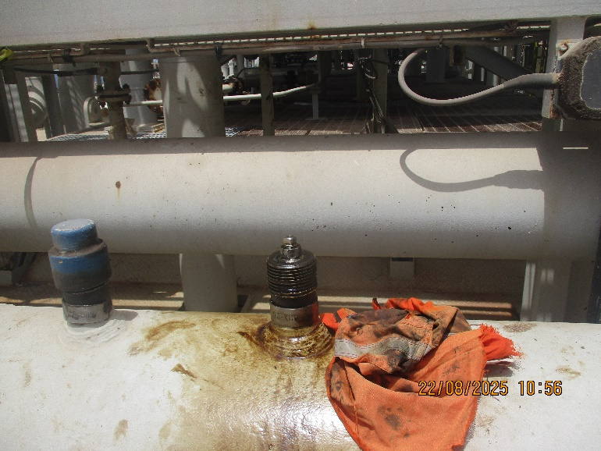 |  |  |  | 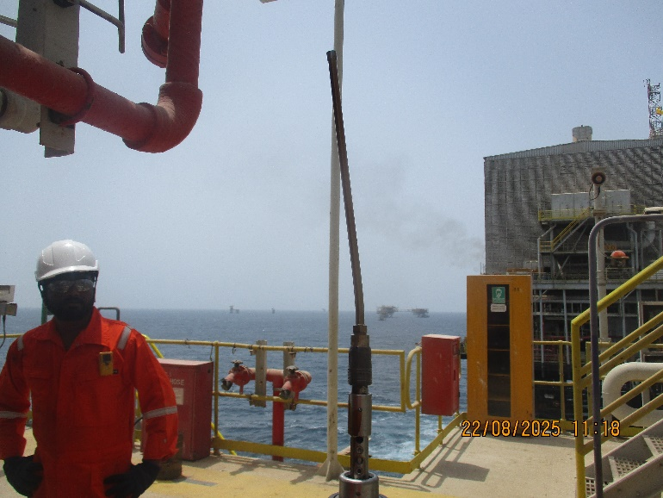 |  |  | 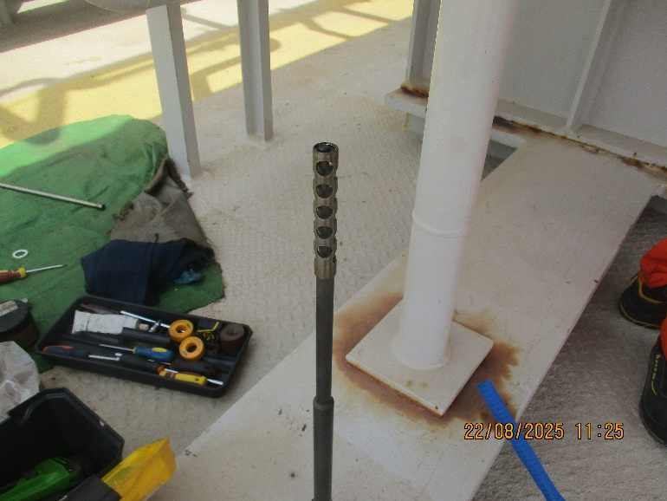
Comments
Retrieved ER Probe (4705-S8-K03005-7-00-01) in bend condition, installed on 27-05-2019

Observations & Recommendations
It was noticed the Retrieved ER Probe (4705-S8-K03005-7-00-01) in bend condition, installed on 27-05-2019

24 Hour Lookahead
The plan for Saturday 23rd August is to continue with coupon and probe replacements on PS-3C Platform.

Shuaib Palakkavalappil – PETROMECH. – shuaib.p@petromech.com.qa

